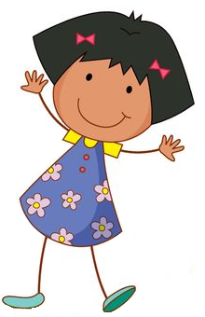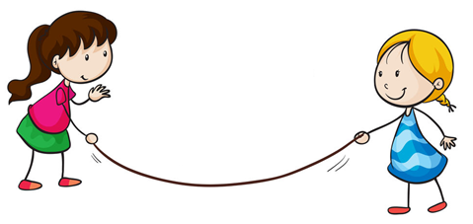

**LEGO**

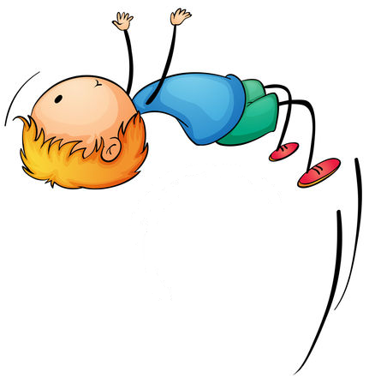

**Play Box**

**Life Orientation & Life Skills**



Written in partnership with



**Contents:**

Introduction … 2

Personal Strengths … 3

Emotions … 4

Dealing with Conflict … 5

Bullying … 6

Peer Pressure … 7

Water Safety … 8

Road Safety … 9

Safety in the Home …10

Festivals & Customs …11

Caring for Animals …12

3D Heart Art …13

Careers …15

Environmental Health …16

Rights & Responsibilities …17

**Introduction**

**Personal Strengths**

**CAPS alignment:**

|  |  |  |  |  |
| --- | --- | --- | --- | --- |
| Grades | Learning area | Study area | Topic | Sub-topic |
| Gr. 4 - 6 | Life Skills | Personal & social well-being | Development of the self | Personal strengths & positive self-esteem |
| Gr. 7-8 | Life Orientation | | Development of the self | Self-image & self concept formation |

**Introduction:** Did you know that no two people in the world are exactly the same? You are a unique and special person. This means that you are good at some things but another person may be good at completely different things. We call these things our personal strengths.

**Building task I:** Build yourself out of LEGO pieces. Choose pieces that help to describe who you are and what makes you special and unique. Choose pieces that show what things you are good at.

**Discussion:**

* *What did you build?*
* *What does it tell us about you that is different from everybody else?*
* *What does your picture tell us about what things you are good at?*
* *How can your personal strengths help the people around you?*

**Building task II:** Add some other people to your model to show how your personal strengths are different from the people around you. See if you can show how you could help other people by doing the things you are good at.

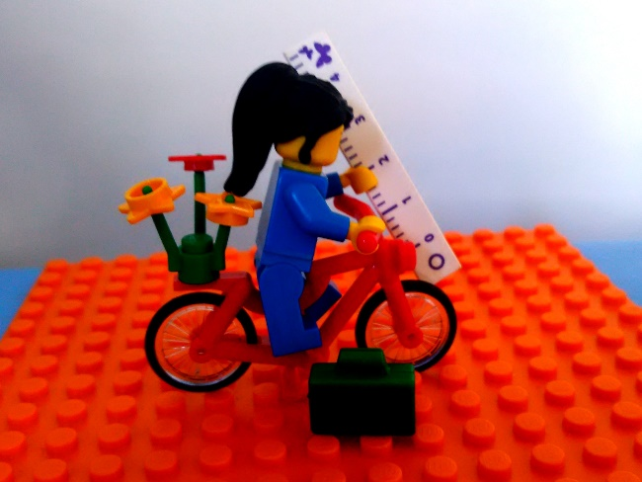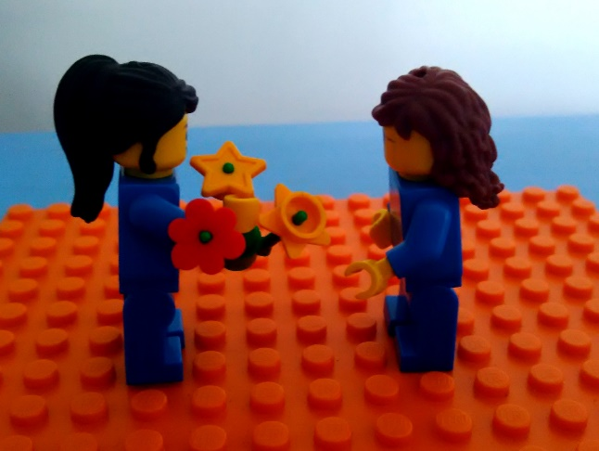

**Emotions**

**CAPS alignment:**

|  |  |  |  |  |
| --- | --- | --- | --- | --- |
| Grades | Learning area | Study area | Topic | Sub-topic |
| Gr. 4 - 6 | Life Skills | Personal & social well-being | Development of the self | Understanding and coping with emotions |

**Introduction:** Humans can feel all kinds of different things. We can feel happy, sad, angry, frightened, worried, excited and embarrassed. These are called emotions. What other emotions can you think of?

**Building task I:**

* Build a sad person
* Build a frightened person
* Build an angry person
* Build a worried person

**Discussion:**

* *What did you build?*
* *What could you do to help the person in the model?*
* *Could you change the person in the model from feeling sad / angry / worried to feeling something else? What could you do if you can’t change the way the person feels?*
* *What kinds of things do you do to help yourself when you are sad / angry / worried?*

**Building task II:** Change the person in your model to a happy or peaceful person. What is different about your model now?

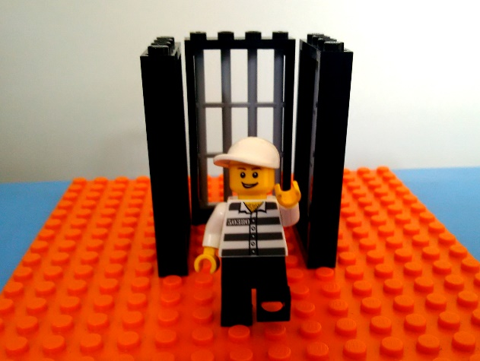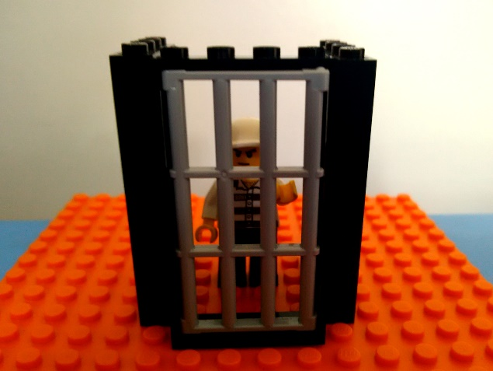

**Dealing with Conflict**

**CAPS alignment:**

|  |  |  |  |  |
| --- | --- | --- | --- | --- |
| Grades | Learning area | Study area | Topic | Sub-topic |
| Gr. 4 - 6 | Life Skills | Personal & social well-being | Development of the self | Dealing with conflict |

**Introduction:** A conflict situation is a situation where two or more people have a serious disagreement or argument about something. Often people feel stuck in conflict situations and find it difficult to work their way out of them.

**Building task I:** Build a scene where people are fighting or arguing about something.

**Discussion:**

* *Show your model to the person sitting next to you.*
* *What are the people fighting or arguing about?*
* *What problems can you see between the people in the model?*
* *See if you can help one another to figure out how the people in your models could fix their problems or resolve their conflict.*

**Building task II:** Build a new model to show how the fight or argument in the first model could be resolved.

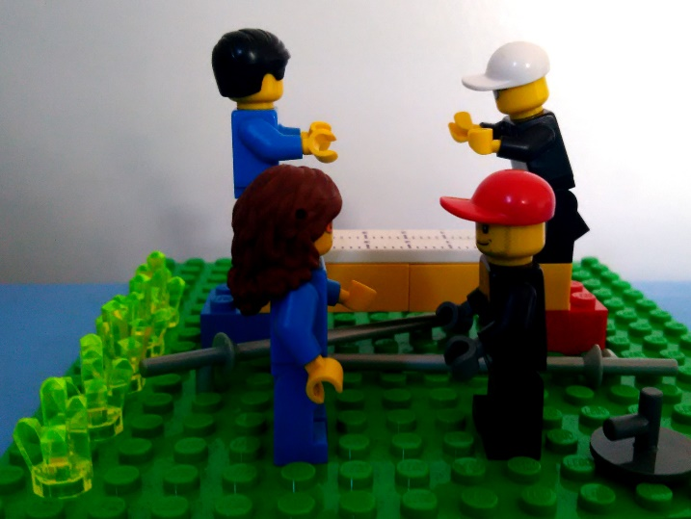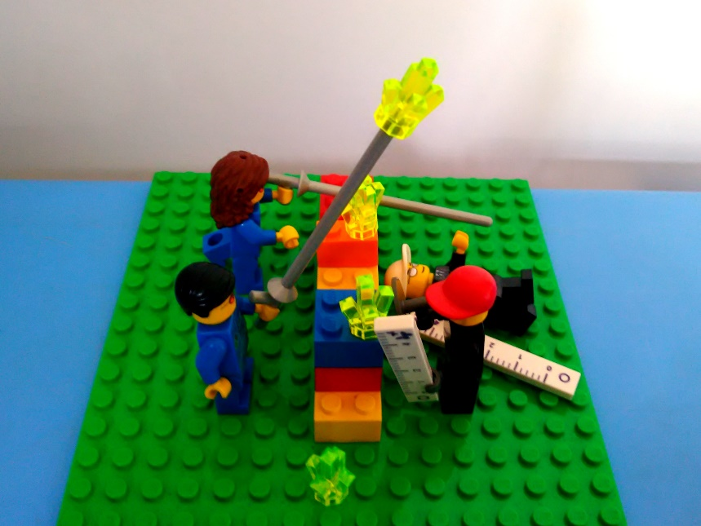

**Bullying**

**CAPS alignment:**

|  |  |  |  |  |
| --- | --- | --- | --- | --- |
| Grades | Learning area | Study area | Topic | Sub-topic |
| Gr. 4 - 6 | Life Skills | Personal & social well-being | Development of the self | Bullying |

**Introduction:**

**Building task I:** Build a scene where one person (or a group of people) are bullying another person.

**Discussion:**

* *Who in the model is / are the bully / bullies and who is being bullied?*
* *Have you ever been in a situation like this? Were you the bully or the person being bullied?*
* *What should the person who is being bullied do?*
* *What should the bully do?*
* *What other person or people could be brought in to help in this situation?*

**Building task II:** Add an extra person to your model to show who could be brought in to the bullying situation to help.

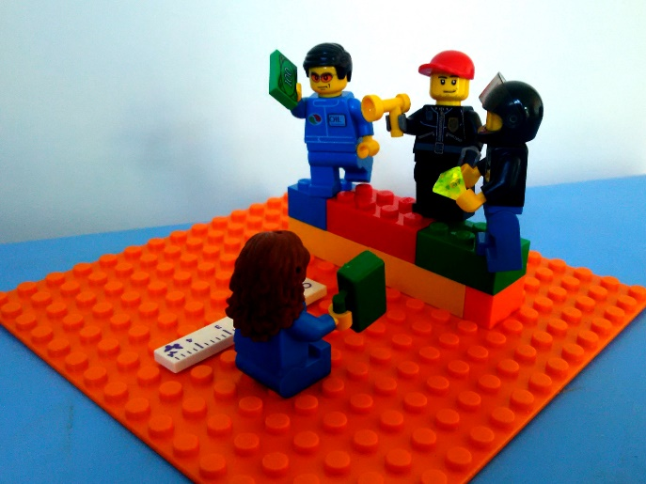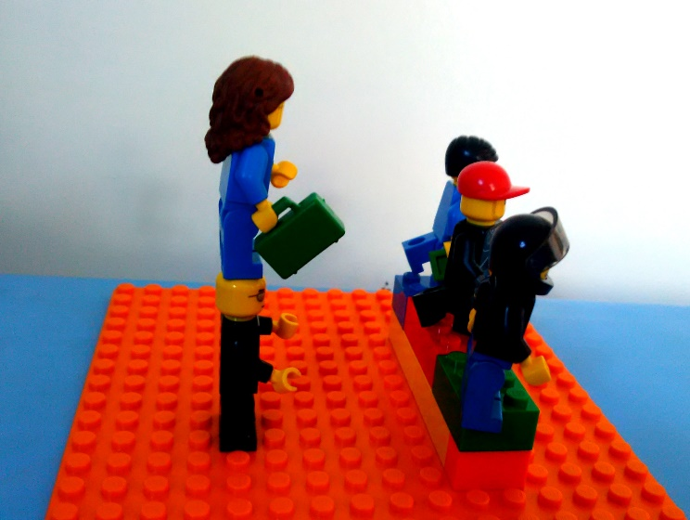

**Peer Pressure**

**CAPS alignment:**

|  |  |  |  |  |
| --- | --- | --- | --- | --- |
| Grades | Learning area | Study area | Topic | Sub-topic |
| Gr. 4 - 6 | Life Skills | Personal & social well-being | Development of the self | Peer Pressure |
| Gr. 7 | Life Orientation | | Development of the self | Peer Pressure |

**Introduction:**

A peer is another person who is a similar age and in similar social circles to you. Peers can have a good or bad influence on you. Sometimes people make bad choices and do things that are harmful to themselves and others, in order to impress their peers. This is called negative peer pressure. Can you think of some examples of this?

**Building task I:** Build a scene from your own life where a friend or peer put pressure on you to do something that you knew you shouldn’t do. If you can’t think of a situation from your own life, you can make one up.

**Discussion:**

* *What in the person in the model being pressured to do? How does that person feel?*
* *If this situation happened to you in real life, how did you handle it?*
* *Would you do anything differently next time?*
* *What can parents or teachers do to help people in situations like this?*
* *Why do you think the other person in the model is trying to put pressure on you?*
* *Why is it important to learn to say “no” to peer pressure?*

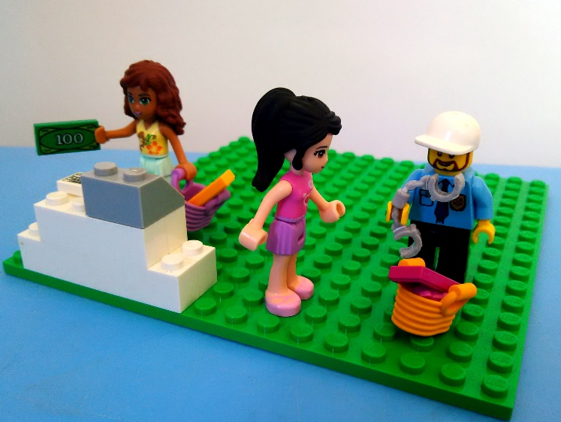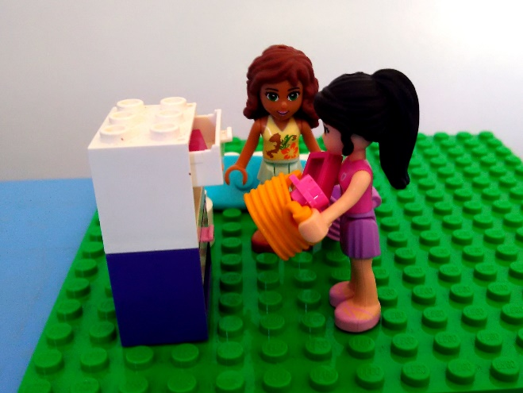**Building task II:** Change the scene to show what might happen after the person says “no” to what the other person is pressurising them to do.

**Water Safety**

**CAPS alignment:**

|  |  |  |  |  |
| --- | --- | --- | --- | --- |
| Grades | Learning area | Study area | Topic | Sub-topic |
| Gr. 4 - 6 | Life Skills | Personal & social well-being | Health & environmental well-being | Dangers in and around water |

**Introduction:** Water can be lots of fun, but can also be very dangerous. A baby can drown in even a little bit of water in the bath. There are lots of places with water that can be fun but we also need to be very careful.

**Building task I:** In groups, build a water feature (e.g. a swimming pool, beach, river, bath) with people playing in it. Then identify the things in the model that are unsafe by placing flags on them.

**Discussion:**

* *Why have you placed flags in those places? What makes those things unsafe?*
* *Who are they unsafe for? Everybody or just some people?*
* *What accidents could happen in this scene?*
* *What could be done to make this place safer?*

**Building task II:** Make changes to your model to show what things you would put in place to make this water feature safe for everyone.

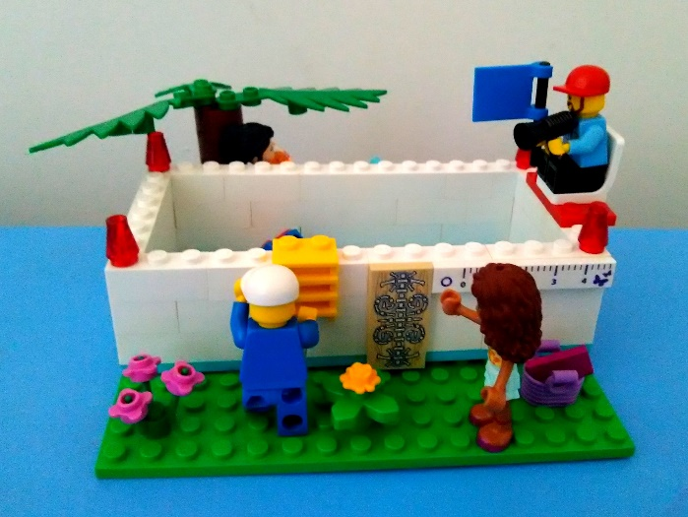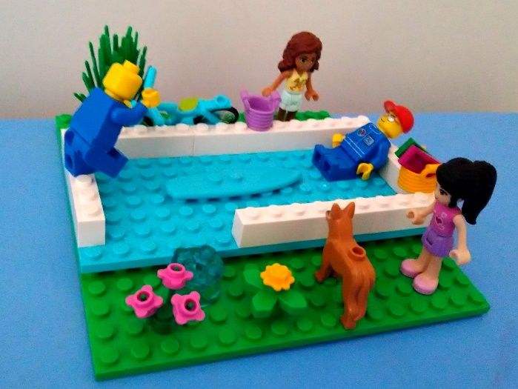

**Road Safety**

**CAPS alignment:**

|  |  |  |  |  |
| --- | --- | --- | --- | --- |
| Grades | Learning area | Study area | Topic | Sub-topic |
| Gr. 4 - 6 | Life Skills | Personal & social well-being | Health & environmental well-being | Traffic rules |

**Introduction:** There are lots of different ways in which to travel from one place to another. No matter which you use, there are always risks when you travel on roads. It is very important to be careful on the road, even if you are a pedestrian or cyclist.

**Building task I:** In groups, build a set of roads with cars, bicycles and pedestrians on it. Include all the things that we usually have on our roads to keep people safe.

**Discussion:**

* *What things did you include in your model that help to keep people safe (e.g. signs, traffic lights, lights, pedestrian crossings, stop streets)?*
* *Who would be protected by each of these safety measures?*
* *Show your model to another group. What extra safety measures do they think could be included?*

**Building task II:** Each person in the group chooses one figure in the model to represent themselves, and one person is nominated to be the “traffic cop”. When the teacher says “go”, all of the group members need to pick up their figures and move them along the roads. They need to be sure to follow all the road safety measures. The traffic cop watches to see if anyone breaks the rules.

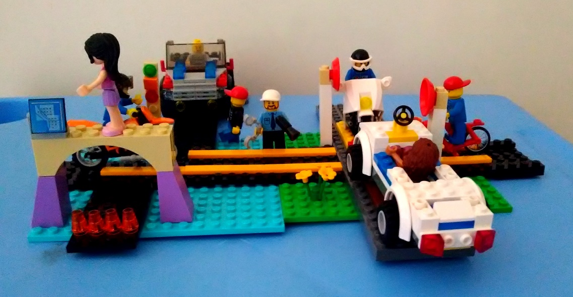

**Safety in the Home**

**CAPS alignment:**

|  |  |  |  |  |
| --- | --- | --- | --- | --- |
| Grades | Learning area | Study area | Topic | Sub-topic |
| Gr. 4 - 6 | Life Skills | Personal & social well-being | Health & environmental well-being | Safety measures at home |

**Introduction:** Different people live in lots of different kinds of homes. Some are big and some are small. Some are made of wood or mud and some are made of bricks or aluminium. Some people have electricity in their homes and others use gas or fire for cooking and lighting. What is your home like?

**Building task I:** Build your home. Build the place where you cook your food, where you sleep and where you wash.

**Discussion:**

* *Look at the model you have built of your home. Is there anything that you think might be unsafe? (e.g. gas, fire, electricity, water, building faults)*
* *What accidents could happen if something went wrong with one of these?*
* *Are there any unsafe things in your home that can’t be seen? (e.g. germs)*
* *What things could your family do to make your home safer?*

**Building task II:** Add to your model any things that you think could make your home safer.

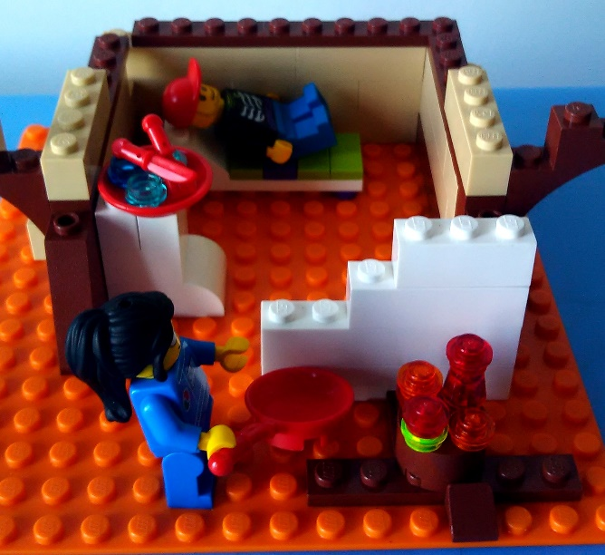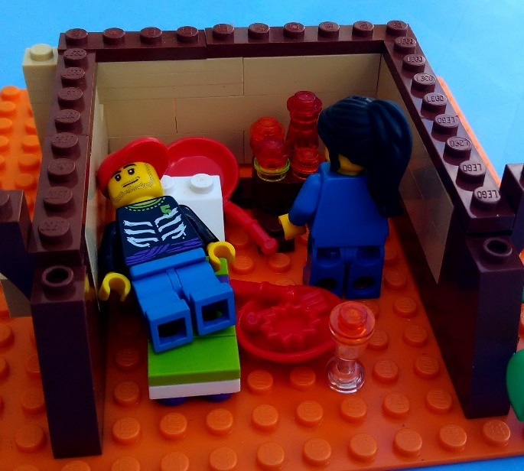

**Festivals and Customs**

**CAPS alignment:**

|  |  |  |  |  |
| --- | --- | --- | --- | --- |
| Grades | Learning area | Study area | Topic | Sub-topic |
| Gr. 4 - 6 | Life Skills | Personal & social well-being | Social responsibility | Festivals & customs |

**Introduction:** There are lots of different cultures and religions in South Africa. Each of these has different festivals that they celebrate and customs that they observe. Can you think of some of the festivals that you know people celebrate (e.g. Ramadan & Eid, Christmas, Easter, Passover, Diwali)?

**Building task I:** Work in groups. Choose one of the festivals that you have discussed as a class and then find a book where you can read about this festival. Use what you have read in the book(s) to help you build a model of people celebrating this festival.

**Discussion:**

* *Show your model to the rest of the class and explain what you have built.*
* *What is similar or different about this festival and a festival that you and your family celebrate?*
* *What things can we learn by understanding the festivals and customs of other people in our country? Why is this important?*

**Building task II:** Swap models with another group in your class. Is there anything you can add to the model based on the new things you have learnt today?

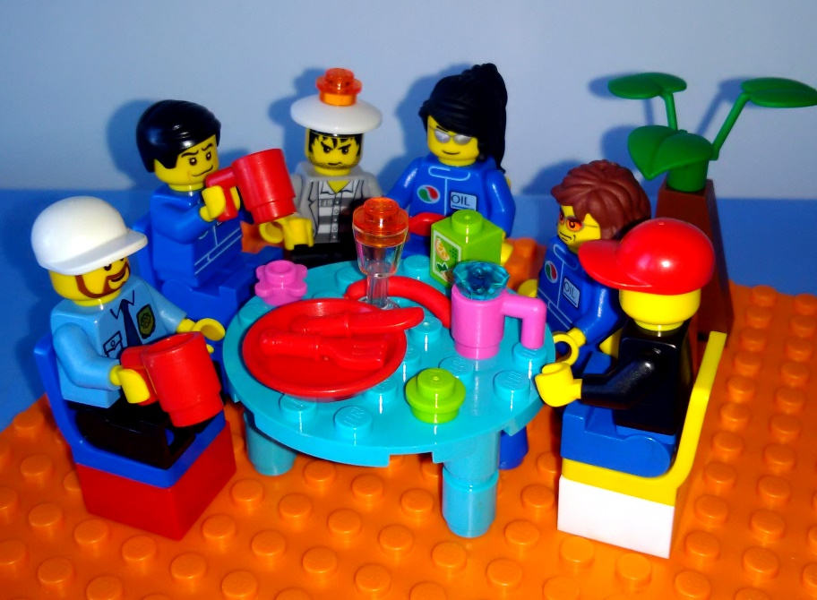

**Caring for Animals**

**CAPS alignment:**

|  |  |  |  |  |
| --- | --- | --- | --- | --- |
| Grades | Learning area | Study area | Topic | Sub-topic |
| Gr. 4 - 6 | Life Skills | Personal & social well-being | Social responsibility | Caring for animals |

**Introduction:** What animals do you see in your everyday life? What animals do the people in your community keep as pets? Animals are important to humans. They help us to do work, they provide companionship and they give us things like milk and eggs, which we eat. But, if someone owns an animal, they also have a responsibility to look after that animal properly.

**Building task I:** Choose a few animals that you see in your everyday life, and build models of these animals out of LEGO bricks.

**Discussion:**

* *What animals did you build (e.g. cats, dogs, cows, sheep, horses)?*
* *Do you think that people have a responsibility to look after these animals?*
* *How should we care for them?*
* *Why do people like to keep animals like cats and dogs as pets?*
* *If you see an animal being badly treated, what should you do about it?*

**Building task II:** Add to the model you built of the animals to show ways in which you could care for those animals and make sure that they are well treated.

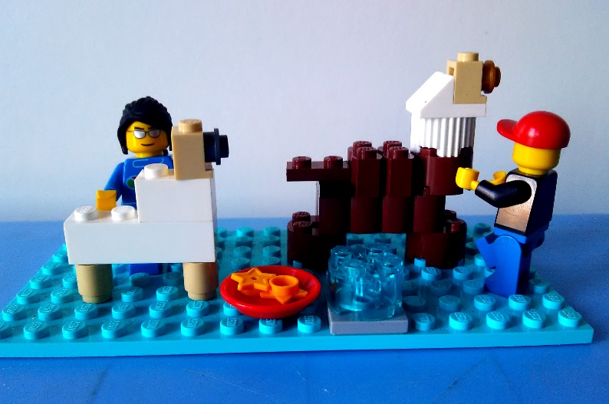

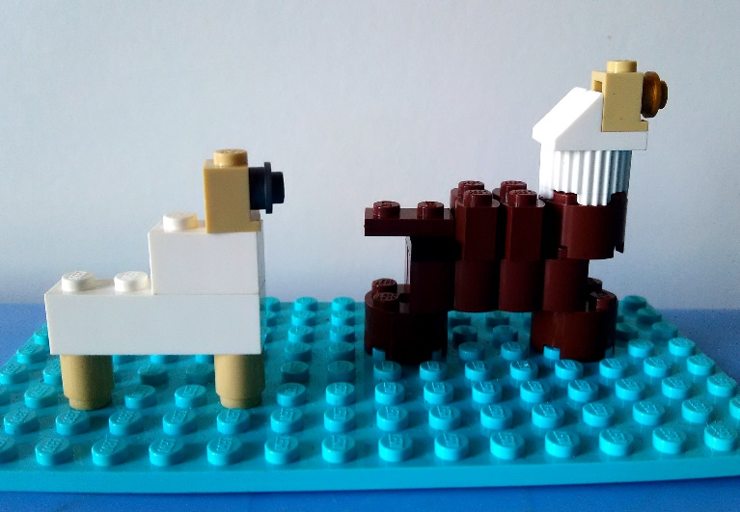

**3D Heart Art**

**CAPS alignment:**

|  |  |  |  |  |
| --- | --- | --- | --- | --- |
| Grades | Learning area | Study area | Topic | Sub-topic |
| Gr. 4 - 6 | Life Skills | Personal & social well-being | Social responsibility | Festivals & customs |
| Gr. 4 - 6 | Life Skills | Visual arts | Create in 3D | 3D hearts |

**Introduction:** Valentine’s Day is a holiday or festival about love that is celebrated all of the world by millions of people. Approximately 150 million cards are exchanged every year on Valentine’s Day. Nobody knows the exact origin of the holiday but one legend says that it was named after a Catholic priest called Valentine who performed weddings for soldiers who were not allowed to get married. Since the Middle Ages people have used heart symbols to represent love.

**Building task I:** When something is flat, we say it has two dimensions (2D). When something has height, length and width, we say it has three dimensions (3D). LEGO bricks are great for building things in 3D. Today, your task is to build a 3D heart out of LEGO.

**Discussion:**

* *What are some of the similarities and differences between the hearts that have been built by members of your class?*
* *How did you go about building your heart?*
* *What makes your heart three-dimensional and not two-dimensional?*

**Building task II:** Build a heart using the pattern below and then place all of your hearts next to each other to make a giant heart pattern.

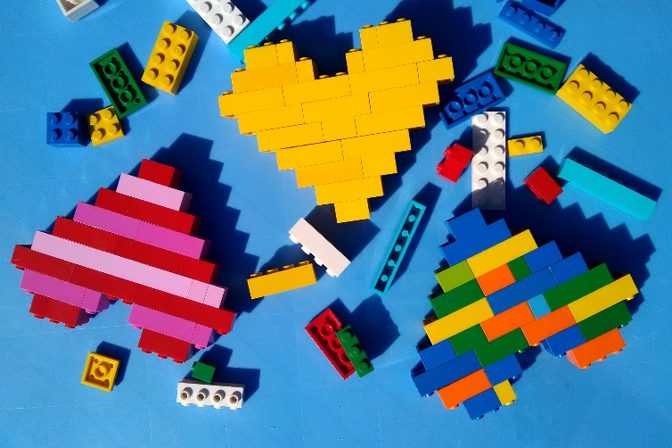

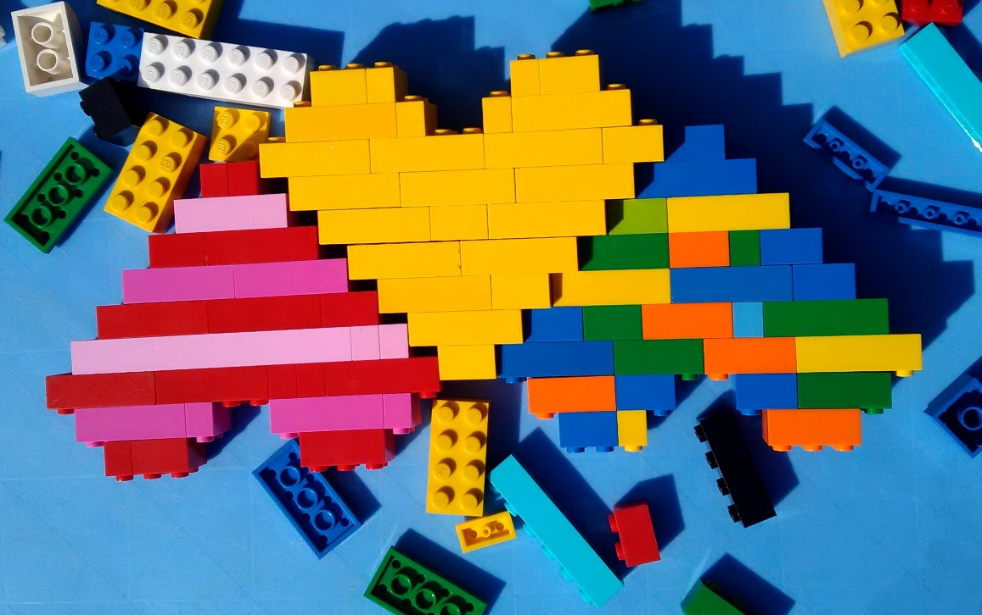

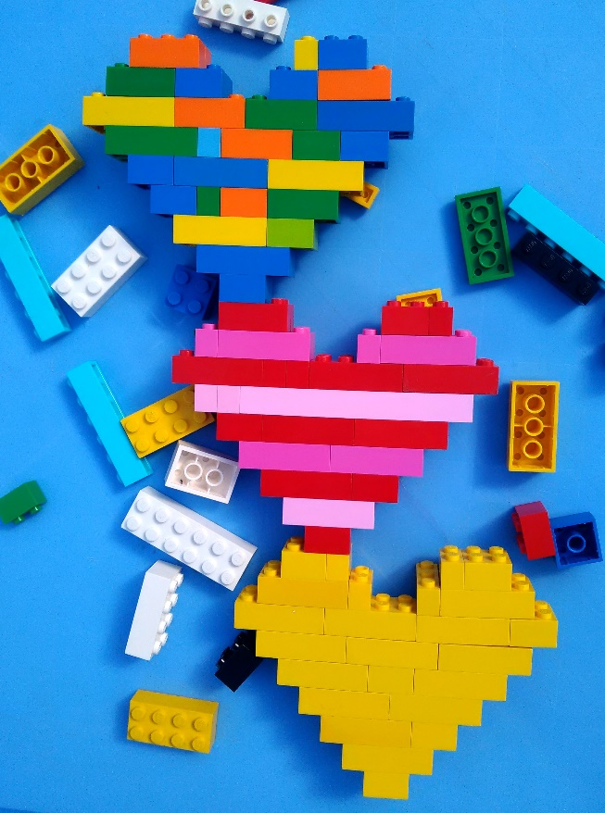

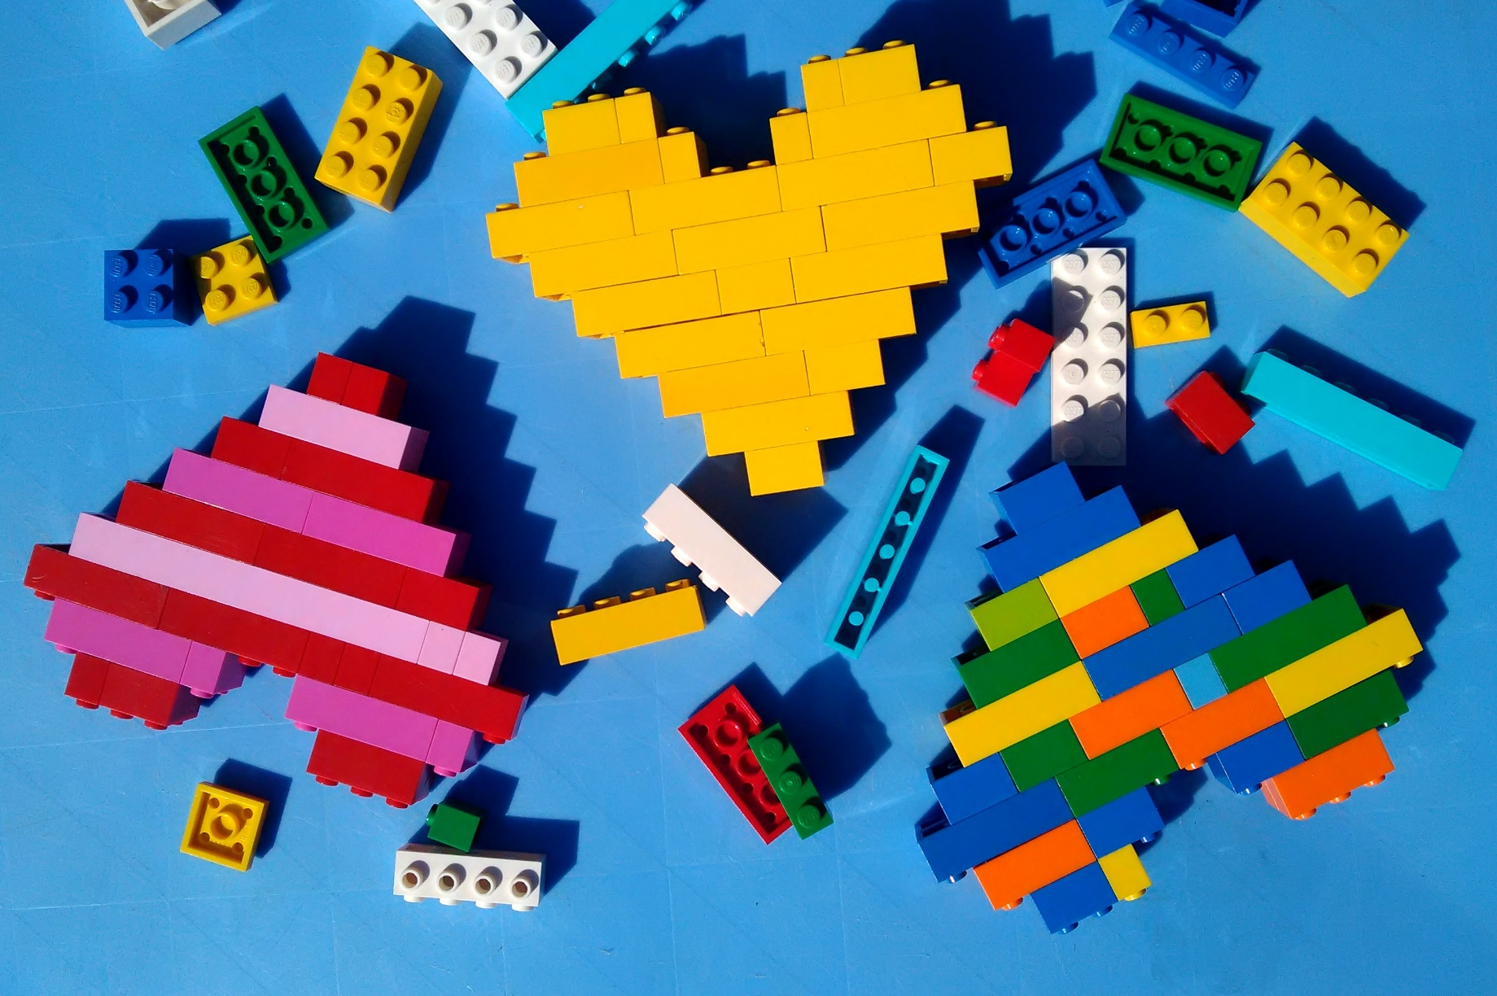

**Careers**

**CAPS alignment:**

|  |  |  |  |
| --- | --- | --- | --- |
| Grades | Learning area | Topic | Sub-topic |
| Gr. 7-9 | Life Orientation | World of work | Careers |

**Introduction:** It is important to plan for your future and to think about what kind of work you would like to do one day. Although you may change your mind many times before then, it is still important to have a goal in mind so that you can do the work that needs to be done to get there.

**Building task I:** Build a model showing yourself now and yourself in your dream career one day. Leave as much space as possible between the two figures or models.

**Discussion:**

* *What career did you build? Why did you choose it?*
* *Do you need a qualification in order to do this job?*
* *What school subjects would you need to take in order to do this job?*
* *What other things will you need to do in order to be able to do this job one day?*

**Building task II:** Between the two models or figures you built in the first exercise, build the steps you will need to take and the qualifications and skills you will need to obtain in order to reach your dream career.

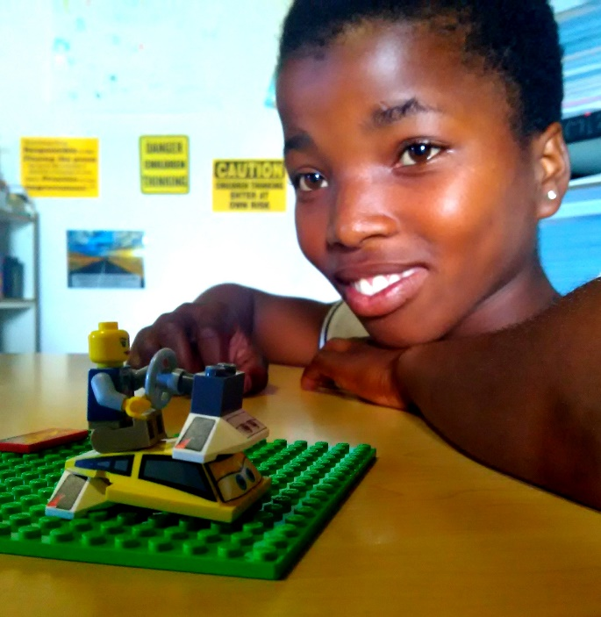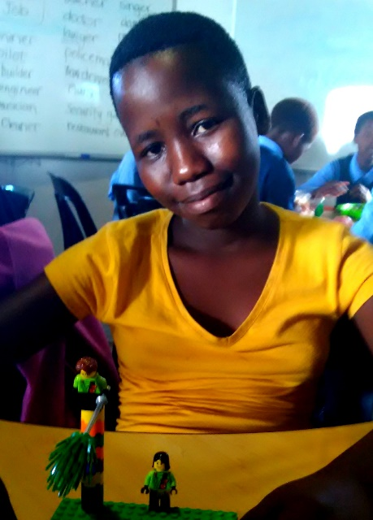

**Environmental Health**

**CAPS alignment:**

|  |  |  |  |
| --- | --- | --- | --- |
| Grades | Learning area | Topic | Sub-topic |
| Gr. 7-9 | Life Orientation | Health, social and environmental responsibility | Environmental health |

**Introduction:** Each student brings a newspaper article relating to an environmental health issue such as air or water pollution, global warming or conservation of the environment.

**Building task I:** Build a model of what you read about in your newspaper article. Show your model to a partner and describe what it is about.

**Discussion:**

* *What did you build?*
* *What problems did you and your partner notice when reading the article or looking at the model?*
* *What could be done to avoid or solve these problems?*
* *Whose responsibility do you think it is to solve these problems?*

**Building task II:** Make changes to your partner’s model to show how you would go about solving the problem. Try to include all the people that would be involved.

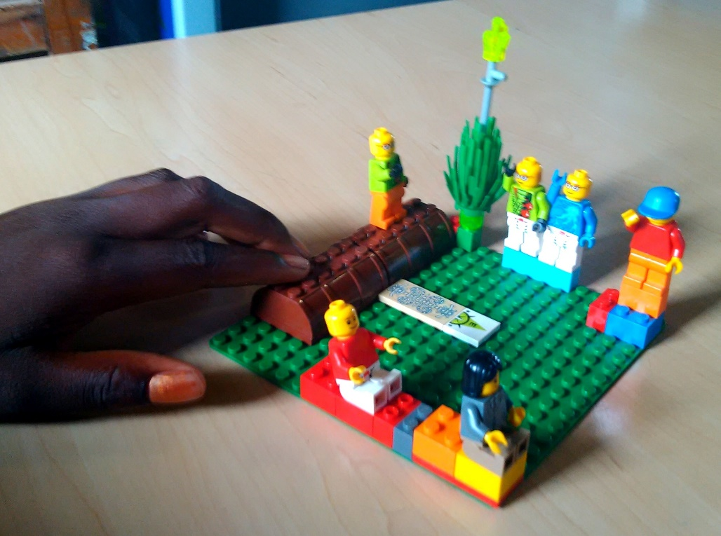

**Rights and Responsibilities**

**CAPS alignment:**

|  |  |  |  |
| --- | --- | --- | --- |
| Grades | Learning area | Topic | Sub-topic |
| Gr. 7-9 | Life Orientation | Constitutional rights and responsibilities | Rights and responsibilities |

**Introduction:** Human rights are the basic rights and freedoms to which all humans are entitled. The South African Constitution stipulates that everyone has the right to equality, human dignity, life, freedom & security, privacy, education, food, clothing, shelter, sanitation, medical services and education. With each of these rights comes an equal responsibility. If we want our rights to be respected, we must not do anything that violates another person’s human rights.

**Building task I:** Build a model that shows one or two of our human rights.

**Discussion:**

* *What did you build?*
* *In what ways is this human right sometimes violated?*
* *What can be done to stop these violations? Whose responsibility is this?*
* *What responsibilities are associated with the rights you have built?*

**Building task II:** Build a second model that illustrates a responsibility that is associated with this right.

